# **17.5W 15V 1A and 5V 0.5A FLYBACK SMPS DESIGN**

$V_{in}$ = 230VAC ${}_{-}^{+}{\%15}$ => 235 $V_{AC}$ < $V_{in}$ < 265 $V_{AC}$

235x $\sqrt{2}$ = 276V Eff (Efficient) = 0,75

̬△ $V_{CAP}$ = % ${}_{-}^{+}{\%15}$

276 x 0,85 = 235V

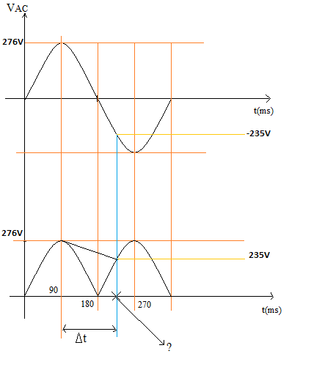



Note: ? = wt

276 x $\sin{wt}$ = -235V

wt = 238°, -58,37°

△t = $\frac{238-90}{180}$ x 10ms = 8,22ms

△ $V_{AVG}$ = $\frac{276+ 235}{2}$ = 255V

$I_{{CAP}_{DISCHARGE}}$ = $\frac{17.5W/0,75}{255}$ = 91.5mA

△V = 276 – 235 = 41V

$\frac{91.5mA}{C}$ x 8,22ms = 41V => C = 18.345uF

230 $V_{AC}$ ${}_{-}^{+}{\%15}$ => $\frac{1uF}{1W}$

Universal input => $\frac{2uF}{1W}$

So 47uF(400V) CAP is chosen

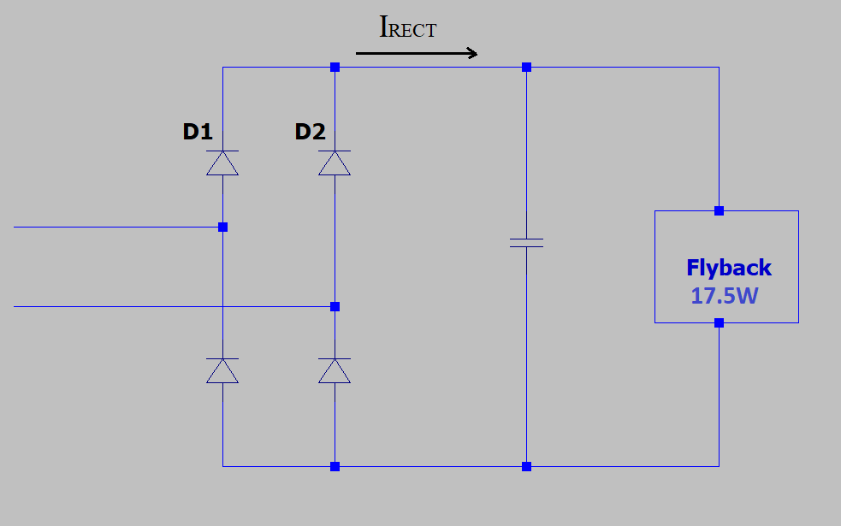

## **# D, L and $L_{P}$

#**

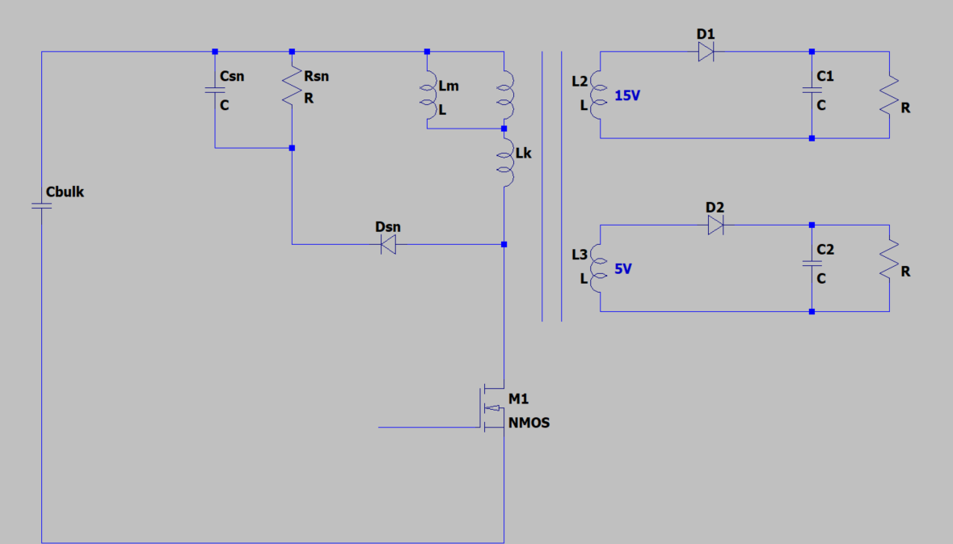

$\frac{Primer}{Seconder}$ = 6 => $\frac{Primer}{15V}$ = 6 => $V_{Reflected}$ = 90V

$K_{L1}$ = $\frac{P_{o1} }{P_{o}}$ = $\frac{15W}{17.5W}$ => $K_{L1}$ =0.857

$K_{L2}$ = $\frac{P_{o2} }{P_{o}}$ = $\frac{2.5W}{17.5W}$ => $K_{L2}$ =0.143

235 x D = 90 x (1 – D) => D = 0,277

$P_{in}$ = $\frac{P_{o} }{η}$ = $\frac{17.5 }{0,75}$ => $P_{in}$ = 23.3W

D = $\sqrt{\frac{2 x P_{in} x L_{peak}}{T}}$ x $\frac{1}{V_{in} }$ => 0,277 = $\sqrt{\frac{2 x 23.3 x L}{15.15u }}$ x $\frac{1}{235 }$ => $L_{pri}$ = 1.378mH

P = $\frac{1}{2} x L_{pri}$ x ${(I_{ds}^{peak})}^{2}$ x f => 33.3 = $\frac{1}{2} x 1.378 x {10}^{-3} x$ ${(I_{L_{peak}})}^{2}$ x 66000 => $I_{ds}^{peak}$ = 0.716A

$I_{S(RMS)}, I_{C(RMS)}, I_{pr(RMS)}$

## $V_{C(AVG)}$**# #**

= 255V => $\frac{255}{1.378mH}$ x $D_{AVG}$ x $\frac{1}{66000}$ = 0.716 => $D_{AVG}$ = 0,255

$I_{S(RMS)} ≅ I_{C\left(RMS\right)} ≅ I_{pr(RMS)}$ $≅ I_{ds}^{peak}$ (@66kHz)

$\frac{1}{\sqrt{3}}$ x $I_{ds}^{peak}$ x $\sqrt{D_{AVG}}$ => $\frac{1}{\sqrt{3}}$ x 0.716 x $\sqrt{0,255}$ => $I_{ds}^{rms}$ = 0.209 $A_{RMS}$

## **# Snubber Power and RCD Snubber**

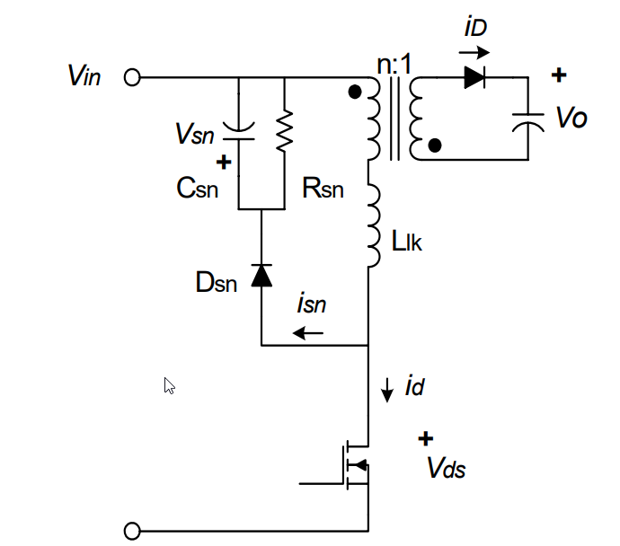

$V_{sn}$ should be 2 $\sim$ 2,5 times of n $V_{O}$.

Therefore $V_{sn}$ = 200V

$L_{K}$ = 0,05 x 1378uH => $L_{K}$ = 69uH

$\frac{1}{2}$ x $L_{K}$ x ${I_{L_{peak}}}^{2}$ x $f_{s}$ = 1.167W So $P_{sn}$ > 1.167W

△t = $\frac{L_{K}}{ V_{sn}-nV_{O}}$ x $I_{L_{peak}}$ = $\frac{69u}{200 -90}$ x3.233 => △t = 450ns

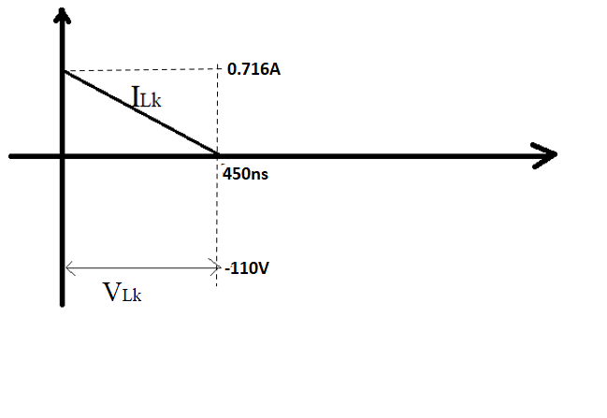

$I_{Lk}$ = 0.716 - $\frac{110}{69uH}$ xt

$I_{Lk}$ = 0 => △t = 115.4ns

$\int_{0}^{450ns}{90 x (}$ 0.716-1.594x ${10}^{6}$ x t)dt = 90x0.716 x 450x ${10}^{-9}$– 90 x 1.594 x ${ 10}^{6}$ x $\frac{{(450x{10}^{-9} )}^{2}}{2}$ =>

= 14.47u joule

$P_{Snubber}$ =66000 x [$\frac{1}{2}$ x 69 x ${10}^{-6}$ x ${0.716}^{2}$ + 14.47 x ${10}^{-6}$] => $P_{Snubber}$ = 2.1W

Rsn = $\frac{{V_{sn}}^{2}}{P_{Snubber}}$ => $\frac{{200}^{2}}{2.1}$ => Rsn = 19047Ω $≅$ 18kΩ

△ $V_{sn}$ = $\frac{V_{sn}}{C_{sn}R_{sn}f_{s}}$ => $C_{sn}=$ = $\frac{200}{20 x 18000x66000}$ = 8.42nF => $C_{sn}$ = 10nF

When the converter operates in DCM at the maximum input voltage and full-load condition, the $I_{peak2}$ is obtained by:

$I_{peak2}$ = $\sqrt{\frac{{2P}_{in}}{f_{s}L_{m}}}$ => $I_{peak2}$ =0.716A

$I_{SEC(RMS)}$

## $I_{sec1}^{rms }$**# #**

= $I_{ds}^{rms }$ x $\sqrt{\frac{1-D_{max}}{D_{max}}}$ x $\frac{V_{RO } x K_{L1}}{V_{o1}}$

$I_{sec1}^{rms }$ = 0.209 x $\sqrt{\frac{1-0.277}{0.277}}$ x $\frac{90 x 0.857}{15}$ => $I_{sec1}^{rms }$ = 1.736Arms

$I_{sec2}^{rms }$ = $I_{ds}^{rms }$ x $\sqrt{\frac{1-D_{max}}{D_{max}}}$ x $\frac{V_{RO } x K_{L2}}{V_{o2}}$

$I_{sec2}^{rms }$ = 0.209 x $\sqrt{\frac{1-0.277}{0.277}}$ x $\frac{90 x 0.143}{5}$ => $I_{sec2}^{rms }$ = 0.87Arms

$I_{sec1}^{peak }$ = 0.716 x 6 x 0.857 => $I_{sec1}^{peak }$ = 3.682A

$I_{sec2}^{peak }$ = 0.716 x 18 x 0.143 => $I_{sec2}^{peak }$ = 1.843A

**# Output Diode #**

265 $\sqrt{2}$ = 375V => 375/6 = 62.22V

$V_{D(peak)}$ = 62.22 +15 => $V_{D1(peak)}$ = 77.22V

265 $\sqrt{2}$ = 375V => 375/18 = 20.83V

$V_{D2(peak)}$ = 20.83 +5 => $V_{D1(peak)}$ = 25.83V

200V diode is suitable. It is SB3200.

$I_{D1(AVG)}$ = $\frac{15W}{15V}$ => $I_{D1(AVG)}$ = 1A

$V_{F}$ = 0,7V $R_{ØJA}$ = 25 °C/W

$P_{LossD}$ = 0,7 x 1 => $P_{LossD}$ = 0,7W

△T = 0,7 x 25°C => △T = 17.5°C

$I_{D2(AVG)}$ = $\frac{2.5W}{55V}$ => $I_{D1(AVG)}$ = 0.5A

$V_{F}$ = 0,7V $R_{ØJA}$ = 25 °C/W

$P_{LossD}$ = 0,7 x 0.5 => $P_{LossD}$ = 0,35W

△T = 0,35 x 25°C => △T = 8.75°C

## **# Snubber Diode ( $D_{sn})$

$V_{DS(peak)}$#**



= 575V

$V_{D_{sn}}$ = 1000V

$V_{DS(RMS)}$ < $V_{D_{sn}(RMS)}$ => So UF4007can be choose.

## **# MOSFET #**

DRAIN Voltage ........................................................ 650 V(min)

DRAIN Pin Peak Current: FSL176MRT................................. 3.5 A

## **# TRANSFORMER #**

**Transformer Core**

EF25(EE2525F)

$A_{e}$ = 51.8 ${mm}^{2}$ $A_{w}$ = 95.3 ${mm}^{2}$

1.378mH x 0.716A = ${N_{pri}}^{min}$ x 0.2T x 51.8 ${mm}^{2}$ => ${N_{pri}}^{min}$ =95.3 turns

${N_{pri}}^{min} ≅$ 108 Turns

${N_{sec1}}^{min} ≅$ 18 Turns

J = 5 A/ ${mm}^{2}$

5A 🡪 1 ${mm}^{2}$

0.209A 🡪 => = 0.0418 ${mm}^{2}$

5A 🡪 1 ${mm}^{2}$

1.736A 🡪 => = 0.3472 ${mm}^{2}$

5A 🡪 1 ${mm}^{2}$

0.87A 🡪 => = 0.174 ${mm}^{2}$

2 x $π{r_{pri}}^{2}$ = 0.26 => $r_{pri}$ $≅$ 0.203mm and $Ø_{pri}$ = 0.406mm (AWG-32)

6 x $π{r_{sec}}^{2}$ = 1.072 => $r_{sec}$ $≅$ 0.24mm and $Ø_{pri}$ = 0.48mm (AWG-26/7/34_TIW) or (AWG25?_TIW)

$A_{cu}$ = 48 x 2 x $π$ x ${0.203}^{2}$ + 12 x 6 x $π$ x ${0.24}^{2}$ => $A_{cu}$ = 25.457

${A_{cu} }/{A_{w} }$ = $\frac{25.457}{148}$ = %17.2 < %25

**Aux winding**

* For FSL176 Vcc = 16V

${N_{aux}}^{min} ≅$ 8 Turns

$π{r_{aux}}^{2}$ = 0.02 $r_{aux}$ $≅$ 0.1mm and $Ø_{aux}$ = 0.2mm (AWG-32)

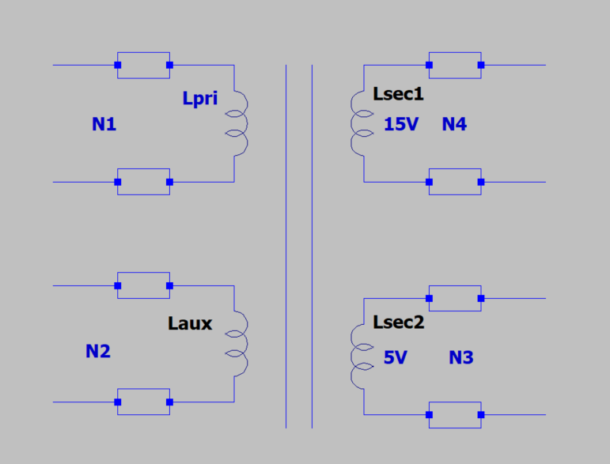

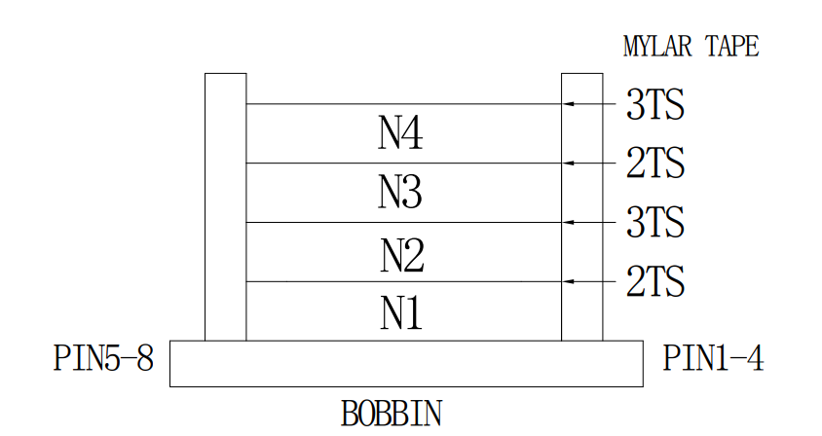

## **# Full Bridge Rectifier**

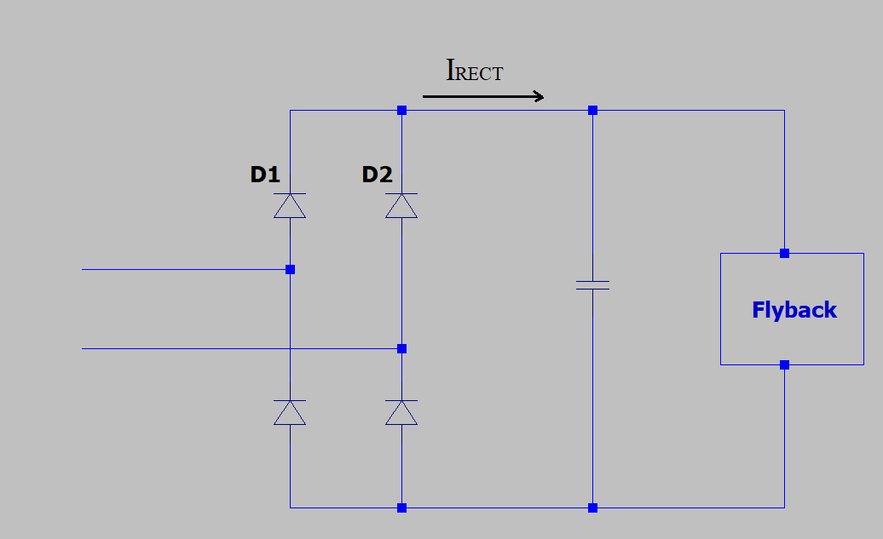

$P_{in}$ =23.3W

$V_{{CAP(AVG)}_{min}}$ =255V

$I_{{RECT}_{AVG}}$ = $\frac{23.3}{255}$ => $I_{{RECT}_{AVG}}$ = 92mA

$I_{{D1}_{AVG}}$ = $I_{{D2}_{AVG}}$ = $\frac{92}{2}$ => $I_{{D1}_{AVG}}$ = $I_{{D2}_{AVG}}$ =46mA

For MB10S:

$P_{D1}$ = 46 x ${10}^{-3}$ x 1 => $P_{D1}$ = 0.046W

$R_{ØJA}$ = 85°C/W

4 x $P_{D1}$ = 4 x 0.46W = 0,184W

△T = 0.184 x 85 => △T $≅$ 15.64°C

## **# NTC - Common Mode Choke

$I_{in(RMS)}$ #**

= $\frac{23.3W}{195V_{RMS}} x \frac{1}{0,7}$ => $I_{in(RMS)}$ = 171m $A_{RMS}$

NTC = B5713S0100 10Ω $C_{Test}$ = 100uF @230 $V_{AC}$

$R_{NTC}$ = 4Ω @171mA

$T_{NTC}$ = 60°C @4Ω

## **# Output Capacitor

$\frac{15W}{15V}$ #**

= 1A

$I_{CO1(RMS)}$ = 1,14 $A_{RMS}$ (@66kHz)

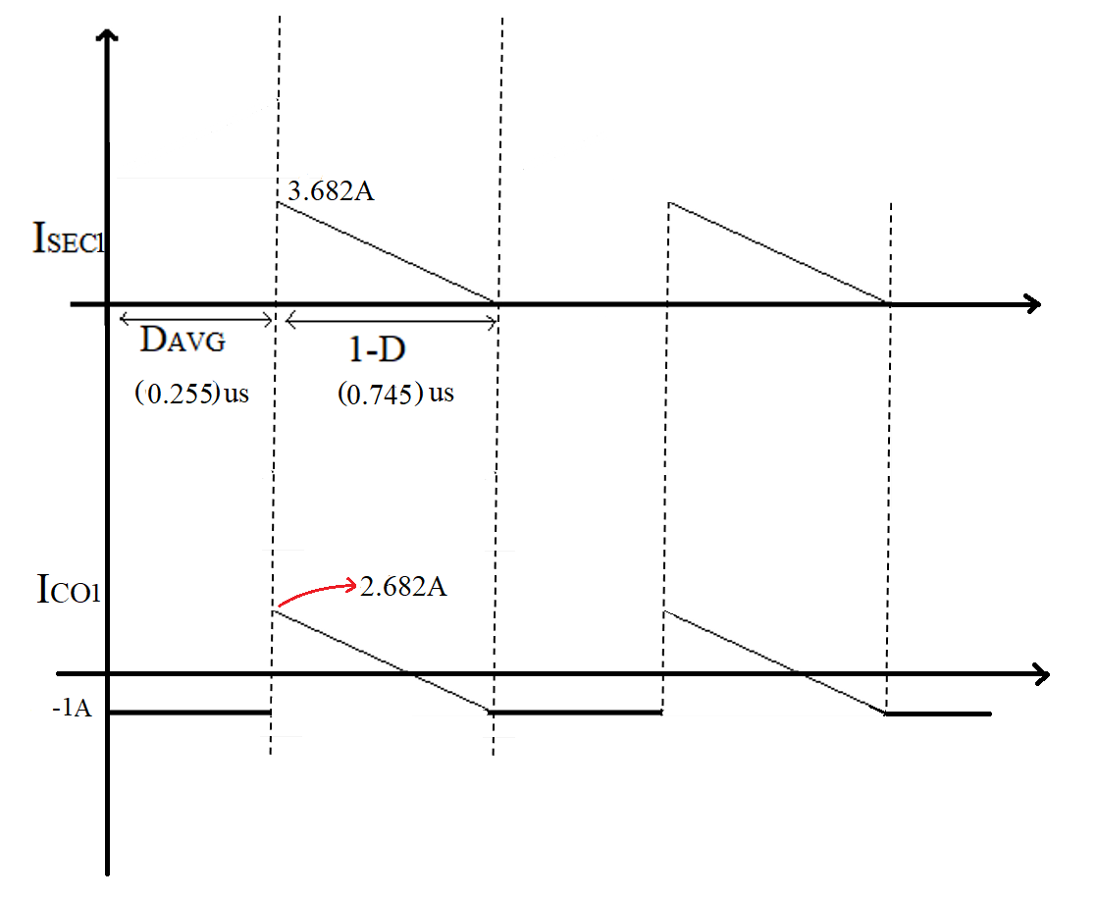

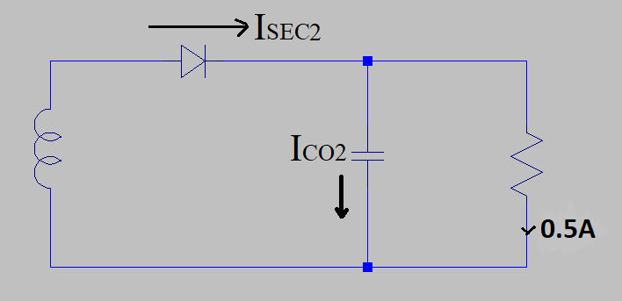 $\frac{2.5W}{5V}$ = 0.5A

$I_{CO2(RMS)}$ = 0.572 $A_{RMS}$ (@66kHz)

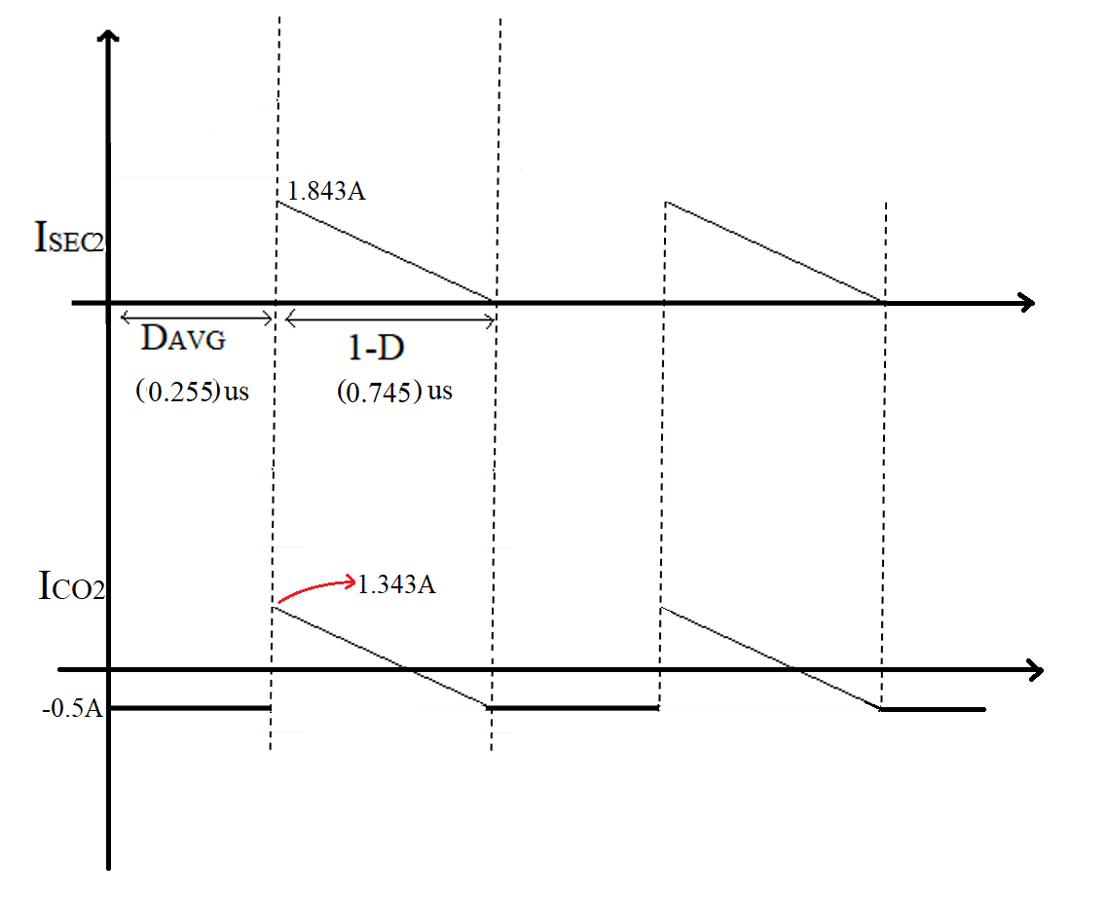

## **# LTSpice Simulation #**

